Opaque Token

🔐 What Is an Opaque Token?
# Source: AI Source: Provided by: [Data Path: Persons Table -> ID Column: 1, Name_En Column: Motasem Essam] -> From: [Chatgpt (GPT‑5 Mini)] on [1/20/2026]
An opaque token is a token whose contents are not meant to be readable or understood by the client or frontend. It’s just a random string — and only the authorization server knows what it represents.

✅ Simple Definition:
# Source: AI Source: Provided by: [Data Path: Persons Table -> ID Column: 1, Name_En Column: Motasem Essam] -> From: [Chatgpt (GPT‑5 Mini)] on [1/20/2026]
An opaque token is a non-transparent access token:
It doesn’t contain any readable data, and it must be validated by the server.

🧠 Real-Life Analogy:
# Source: AI Source: Provided by: [Data Path: Persons Table -> ID Column: 1, Name_En Column: Motasem Essam] -> From: [Chatgpt (GPT‑5 Mini)] on [1/20/2026]
Imagine a cloakroom ticket:
- It has a random number: #7945
- You don’t know what's behind that number — only the cloakroom does.
Same with an opaque token: it means nothing to the client, but the server can look it up.

🆚 Opaque Token vs JWT
# Source: AI Source: Provided by: [Data Path: Persons Table -> ID Column: 1, Name_En Column: Motasem Essam] -> From: [Chatgpt (GPT‑5 Mini)] on [1/20/2026]
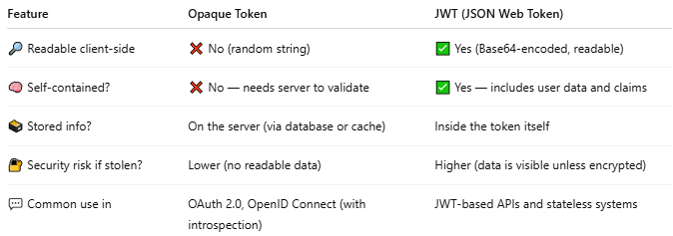

Feature | Opaque Token | JWT (JSON Web Token)
🔎 Readable client-side | ❌ No (random string) | ✅ Yes (Base64-encoded, readable)
🧠 Self-contained? | ❌ No — needs server to validate | ✅ Yes — includes user data and claims
🗃️ Stored info? | On the server (via database or cache) | Inside the token itself
🔐 Security risk if stolen? | Lower (no readable data) | Higher (data is visible unless encrypted)
💬 Common use in | OAuth 2.0, OpenID Connect (with introspection) | JWT-based APIs and stateless systems

📦 What Does an Opaque Token Look Like?
# Source: AI Source: Provided by: [Data Path: Persons Table -> ID Column: 1, Name_En Column: Motasem Essam] -> From: [Chatgpt (GPT‑5 Mini)] on [1/20/2026]
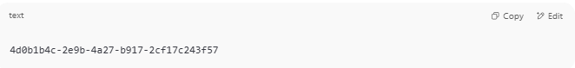
4d0b1b4c-2e9b-4a27-b917-2cf17c243f57

🧊 It’s just a random ID — nothing inside it can be decoded on the client side.

🛠️ How Is It Verified?
# Source: AI Source: Provided by: [Data Path: Persons Table -> ID Column: 1, Name_En Column: Motasem Essam] -> From: [Chatgpt (GPT‑5 Mini)] on [1/20/2026]
The server checks the token against a token store or database, or calls a token introspection endpoint to:
- Confirm it’s valid
- Get user or session data

🛡️ When to Use Opaque Tokens?
# Source: AI Source: Provided by: [Data Path: Persons Table -> ID Column: 1, Name_En Column: Motasem Essam] -> From: [Chatgpt (GPT‑5 Mini)] on [1/20/2026]
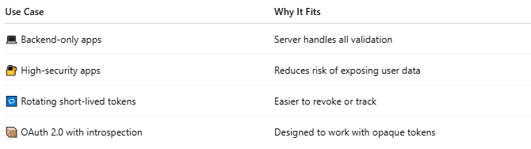

Use Case | Why It Fits
💻 Backend-only apps | Server handles all validation
🔐 High-security apps | Reduces risk of exposing user data
🔁 Rotating short-lived tokens | Easier to revoke or track
📦 OAuth 2.0 with introspection | Designed to work with opaque tokens

📌 Summary
# Source: AI Source: Provided by: [Data Path: Persons Table -> ID Column: 1, Name_En Column: Motasem Essam] -> From: [Chatgpt (GPT‑5 Mini)] on [1/20/2026]
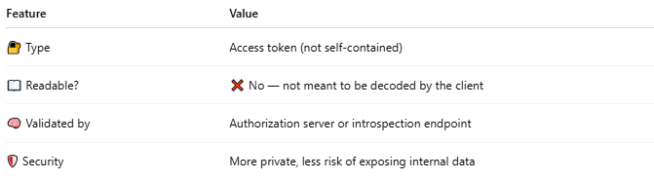

Feature | Value
🔐 Type | Access token (not self-contained)
📖 Readable? | ❌ No — not meant to be decoded by the client
🧠 Validated by | Authorization server or introspection endpoint
🛡️ Security | More private, less risk of exposing internal data

